**shipCalculator_SW**

This console app consume an WebAPI (https://swapi.co/) that provides you a list of starships and calculate how many stops do they need to travel a distance in mega lights.

# What it does?

You need to input an integer value that will be the mega lights you want to travel. If the value is not an integer, the program will return an error and ask you to input a new value.

# How do I run it ?

You will find the executable in folder "shipCalculator_SW\ShipCalculator\ShipCalculator\bin\Debug" and the file name is ShipCalculator.exe

# Required

* As it was developed with .NET Framework 4.5. You will need to get it installed. You can download it from this link:<https://www.microsoft.com/es-ar/download/details.aspx?id=30653>
* You also need to have internet connection to run the application.

# Results

After you input a value and press Enter. Application will show you this message : "Getting info from server...". While we get data from server. After getting data, it will show you a list of starships and how many stops do they need to travel the input value. If the starship does not include information of consumable or MGLT the result will be unknown.

Otherwise you will see, for example:

Executor: 476

Sentinel-class landing craft: 19841

Death Star: 3805

Millennium Falcon: 9259

Y-wing: 74405

X-wing: 59524

TIE Advanced x1: 79365

# Architecture

The Solution has been defined with 2 principal projects and 1 unit test project:

## ShipCalculator

· This is main project that has the main method that will lunch the console application.

## Calculator_BLL

· In this project you will find all the logic. You will have also 4 principal folders: - Model : all Data Models used. - Helpers : static strings used and all values that are used to calculate the results. - API : Classes that connect you to the <https://swapi.co/>to get the results - Repository: in this folder you will find all methods used to calculate the results for your request

## Unit Tests

· This project also has some Unit Test to run, to get some values and prove that all that you get is expected.

All these test are in a project called ShipCalculator.UnitTests

# Screen Capture

1º screen: here you will have to input a value.

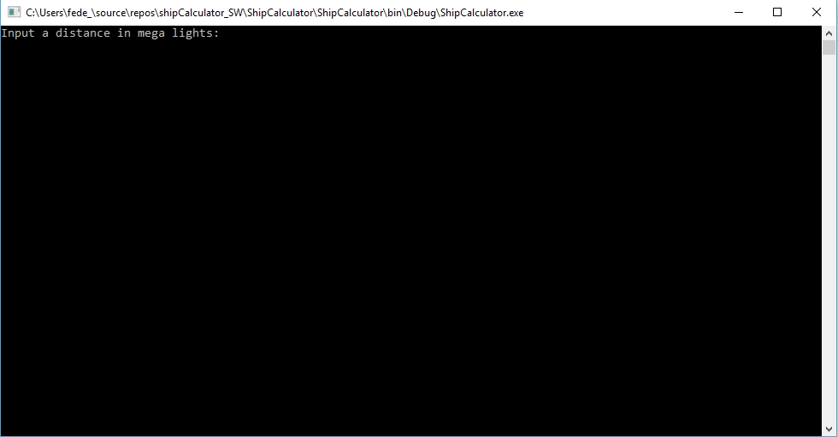

2º screen: After you input a correct value, it will contact a WebAPI to get the data and calculate the values.

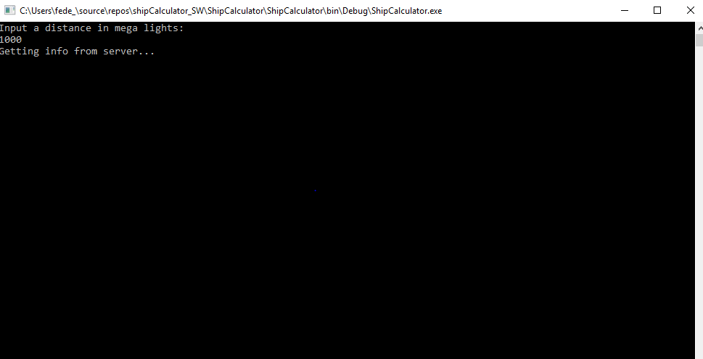

3º screen: After process all data console will print a collection of starships and the result for each one.

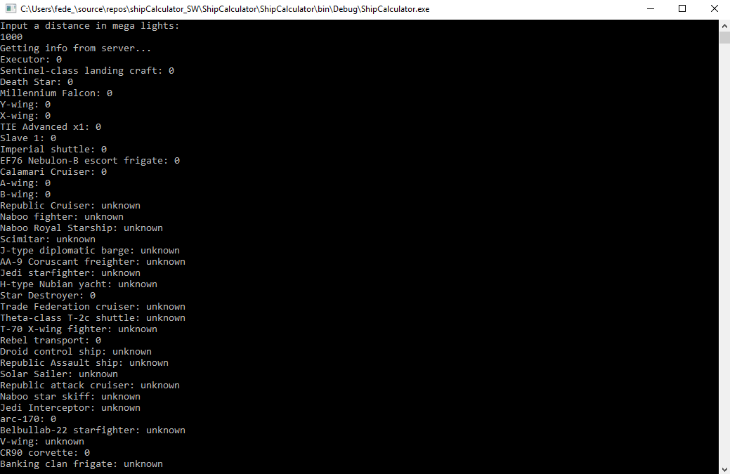

Errors screen

